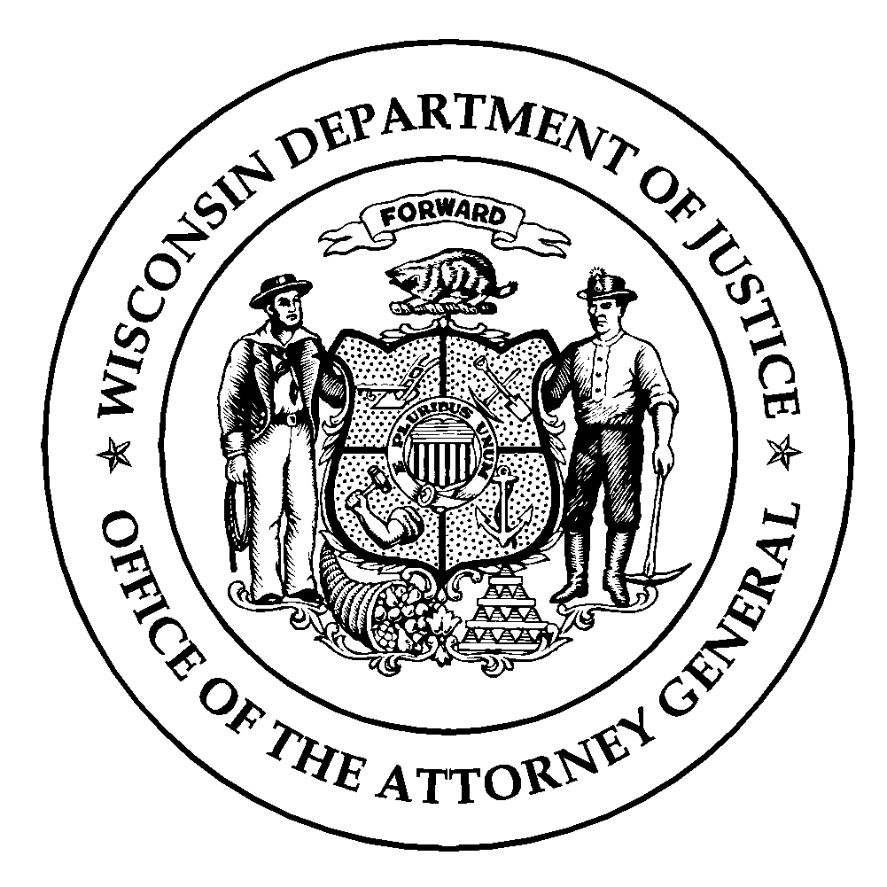Wisconsin Department of Justice
Law Enforcement Standards Board
DJ-LE-340, 8/2026
https://wilenet.widoj.gov/

APPLICATION FOR AN EXTENSION OF THE TIME LIMIT TO COMPLETE PREPARATORY TRAINING

Time frames for completion of preparatory training are set forth in Wisconsin Statute § 165.85(4)(a)3., (4)(b)3., and (4)(c)3. All law enforcement, tribal law enforcement, jail, and secure juvenile detention officers have within their probationary period of employment, not to exceed 12 months from their first date of employment to complete preparatory training. Upon a showing of good cause by a recruit or the recruit’s employer, the Law Enforcement Standards Board (LESB) may extend a recruit’s original probationary period of employment for a period of time the LESB deems appropriate for purposes of completing preparatory training.

Please complete and submit this form to request an extension of the time limit to complete preparatory training.

1. Applicant Name (Last Name, First Name, Middle Initial):

2. Title (Law Enforcement, Jail, or Juvenile Detention Officer):

3. Employing Agency:

4. First Date of Employment:

5. Justification for Extension Request:

6. Is the applicant enrolled in an academy?

Yes No
7. If you answered “Yes” to question #6, please provide the name of the academy and the start date:

8. If you answered “No” to question #6, how much additional time is needed beyond the initial 12 months of employment for the applicant to successfully complete training?

9. Name and Title of Requestor:

10. Requestor Email Address:

11. Date of Request:

Submit this form as an Email Attachment to Nathan White, Compliance Officer at: Nathan.White@wisdoj.gov

