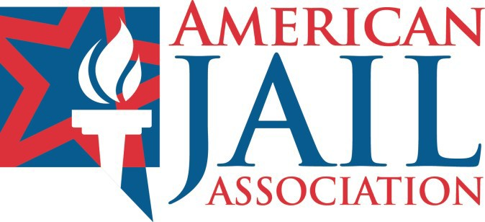AMERICAN JAIL ASSOCIATION

1135 Professional Court

Hagerstown, MD 21740-5853

301–790–3930

Fax 301–790–2941

*aja.org*

SUPPORTING INDIVIDUALS WORKING IN OUR NATION’S JAILS

American Jail Association Code of Ethics for Jail Officers

As an officer employed in a detention/correctional capacity, I swear (or affirm) to be a good citizen and a credit to my community, State, and Nation at all times. I will abstain from questionable behavior which might bring disrepute to the agency for which I work, my family, my community, and my associates. My lifestyle will be above and beyond reproach, and I will constantly strive to set an example of a professional who performs his/her duties according to the laws of our country, State, and community, and the policies, procedures, written and verbal orders, and regulations of the agency for which I work.

On the job I promise to:

**KEEP** the institution secure so as to safeguard my community and the lives of the staff, inmates, and visitors on the premises.

**WORK** with each individual firmly and fairly without regard to rank, status, or condition.

**MAINTAIN** a positive demeanor when confronted with stressful situations of scorn, ridicule, danger, and/or chaos.

**REPORT** either in writing or by word of mouth to the proper authorities those things which should be reported, and keep silent about matters which are to remain confidential according to the laws and rules of the agency and government.

**MANAGE** and supervise the inmates in an evenhanded and courteous manner.

**REFRAIN** at all times from becoming personally involved in the lives of the inmates and their families.

**TREAT** all visitors to the jail with politeness and respect and do my utmost to ensure that they observe the jail regulations.

**TAKE** advantage of all education and training opportunities designed to assist me to become a more competent officer.

**COMMUNICATE** with people in or outside of the jail, whether by phone, written work, or word of mouth, in such a way so as not to reflect in a negative manner upon my agency.

**CONTRIBUTE** to a jail environment which will keep the inmate involved in activities designed to improve his/her attitude and character.

**SUPPORT** all activities of a professional nature through membership and participation that will continue to elevate the status of those who operate our nation’s jails. Do my best through word and deed to present an image to the public at large of a jail professional, committed to progress for an improved and enlightened criminal justice system.

The American Jail Association’s Board of Directors has approved the AJA Code of Ethics as part of an integral program to achieve a high standard of professional conduct among those officers employed in our Nation’s jails.

*Adopted by the American Jail Association Board of Directors on November 10, 1991.*

*Revised on May 19, 1993.*

*Re-affirmed on May 3, 2008, by the AJA Board of Directors in Sacramento, California.*

I have received and read the AJA Code of Ethics. I will live up to this code throughout my career.

__________________________________ ____________________________________

Printed Name Signature

__________________________________

Date