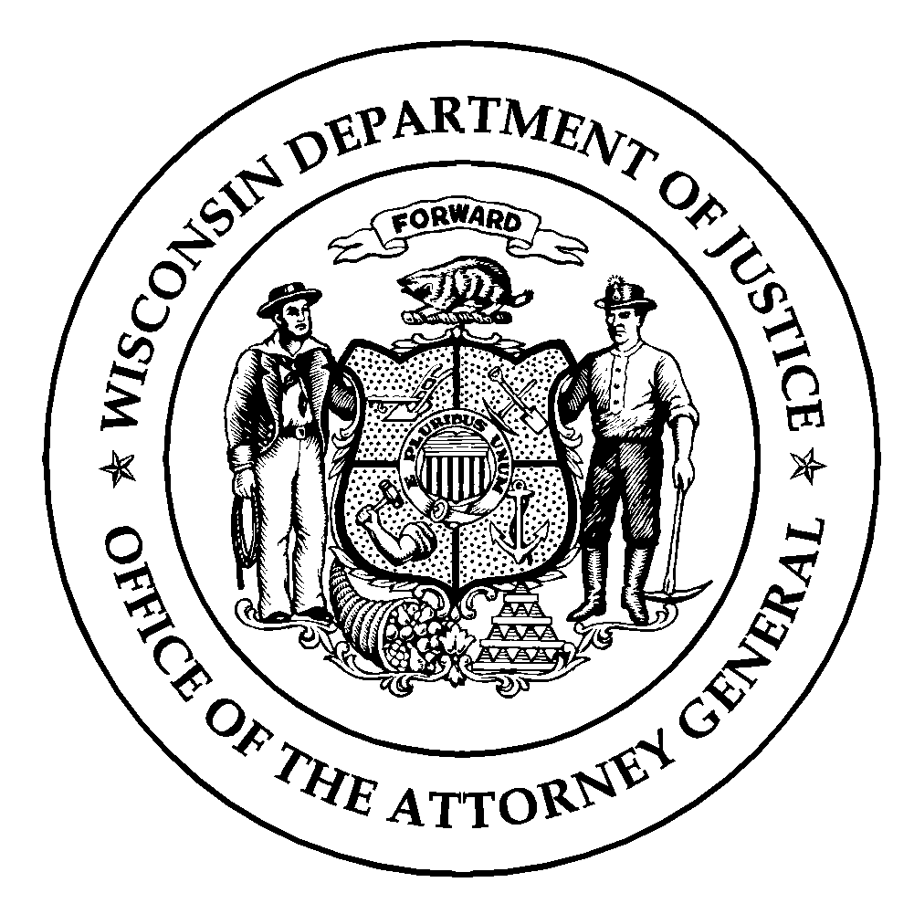**Wisconsin Department of Justice**

**Law Enforcement Standards Board**

**DJ-LE- 329, Rev. 10/12**

**https://wilenet.widoj.gov/**

**CRIMINAL JUSTICE / LAW ENFORCEMENT ASSOCIATE DEGREE CERTIFICATION TRACK STUDENT DECLARATION**

The Wisconsin Law Enforcement Standards Board (LESB) is charged, in part, with the establishment of minimum eligibility standards for employment as a law enforcement or tribal law enforcement officer, and minimum educational and training standards for law enforcement and tribal law enforcement certification.

Since June 2, 1992, the LESB has approved the incorporation of basic law enforcement officer training competencies, learning objectives and performance standards from the basic law enforcement officer training academy into a Criminal Justice / Law Enforcement (CJ / LE) Associate Degree Program.

There are two tracks to the CJ / LE Associate Degree Program:

* **CertificationTrack *–*** *Successful completion leads to* ***eligibility*** *for law enforcement officer certification with the LESB.*
* **Non-CertificationTrack *-*** *Associate Degree is granted, however student is* ***not eligible*** *for law enforcement officer certification at the completion of the program.*

**CJ / LE Associate Degree Certification Track Course Prerequisites**

To be eligible to participate in a course that includes LESB-approved curriculum, CJ / LE Associate Degree Certification Track Students must meet the following prerequisites, and the training provider must maintain documentation showing that the prerequisites have been met:

* Be at least 17 years of age and enrolled as a Wisconsin Technical College System associate degree student. Proof of age is required (form DJ-LE-322, *Birth Certificate Verification* form).
* Possess a general educational development diploma or be a high school graduate who has completed a secondary education program through a public school, private school, an equivalency diploma program, or home education program within the United States or its territories. Criteria for proof of compliance includes any of the following: a general educational development diploma; a high school diploma issued by a public school education program; a high school diploma issued by a private school; a high school equivalency diploma; or copies of form PI-1206 filed with the Department of Public Instruction for applicants who have completed a home school program in Wisconsin, or documentation that the education program has met the requirements of the Department of Education from the state where the home school program was completed.
* Complete the *Application for Enrollment in Law Enforcement, Jail or Secure Juvenile Detention Officer Basic Training* (form DJ-LE-327)*.*
* Sign and file the *Student Authorization for Release of Information* (form DJ-LE-310).
* Sign and acknowledge compliance with the CJ / LE Associate Degree Program Rules, Penalties and Grievance Procedures.
* Sign and acknowledge compliance with the CJ / LE Associate Degree Program Grading Policy.
* Sign and date this Student Declaration form (form DJ-LE-329) declaring your intent to complete the CJ / LE Associate Degree Certification Track Program.

**Tactical Course Enrollment Prerequisites**

To be eligible to enroll in courses containing the following tactical topics: Firearms, Defensive and Arrest Tactics, Emergency Vehicle Operations and Control, and Vehicle Contacts; CJ / LE Associate Degree Certification Track Students must meet the following additional prerequisites, and the training provider must maintain documentation showing that the prerequisites have been met:

* Complete an oral interview screening with criminal justice executives or with teaching or counseling staff affiliated with the technical college.
* Undergo a criminal history records check, and not be prohibited by federal or state law from possessing a firearm.
* Possess a valid Wisconsin driver’s license or other valid operator’s permit recognized by the Wisconsin Department of Transportation as authorizing driving/operation of a motor vehicle.
* Complete a physical/medical assessment to verify that you can meet the physical standards required of a law enforcement officer (form DJ-LE-322, *Physician’s Assessment* form).
* Provide proof of United States Citizenship (form DJ-LE-322, *Birth Certificate Verification* form).
* Be administered, sign and file the Law Enforcement Code of Ethics as written in Wisconsin Administrative Code Section LES 3.01(1)(d), as an oath.

**Academic and Behavioral Expectations**

Certification Track Students must maintain personal integrity through truthfulness and ethical behavior. Contacts with law enforcement must be reported to faculty and/or the academy director within three (3) days of occurrence.

**“Certifiability” Requirements**

To be eligible for law enforcement officer certification (“certifiable status”), Certification Track Students must complete all CJ / LE Associate Degree Courses, including tactical courses, and the final scenario-based evaluation within three (3) years. The clock starts for a Certification Track Student on the first day the student enters into a CJ / LE Associate Degree Course (i.e. Introduction to Criminal Justice).

**“Certifiable” Status**

Certification Track Students who successfully complete basic training within the CJ / LE Associate Degree Certification Track Program are “certifiable” for three (3) years following their date of program completion. Students who do not gain Wisconsin law enforcement employment within three (3) years will lose their “certifiable” status.

**STUDENT DECLARATION**

I have read and understand the conditions and requirements for the CJ/LE Associate Degree Certification Track Program, and I **do not** wish to participate as a Certification Track Student. If I change my mind and decide that I do want to participate as a Certification Track Student, I understand that I will need to sign a new declaration, and that I will re-complete all core courses taken as a Non-Certification Track Student.

|  |  |  |
| --- | --- | --- |
|  |  |  |
|  |  |  |
| *Student Signature* |  | *Date* |
|  |  |  |
|  |  |  |
| *Student Name (Print)* |  |  |

I have read and understand the conditions and requirements for the CJ / LE Associate Degree Certification Track Program, and I declare my intent to complete this Program. I have also read and understand the conditions and requirements for employment as a law enforcement officer set forth in Wisconsin Administrative Code Chapter LES 2, and included on pages 3 and 4 of this application.

I understand, to be eligible for “certifiable” status, I must complete all requirements **within a three (3) year time frame, beginning with my first CJ / LE Associate Degree Course.** My Certification Track participation commenced on the 1st day of the semester (listed below) and will terminate three (3) years from that date.

|  |  |  |
| --- | --- | --- |
|  |  |  |
|  |  |  |
| *Student Signature* |  | *Date* |
|  |  |  |
|  |  |  |
| *Student Name (Print)* |  | *(Semester Start Date)* |

**EMPLOYMENT STANDARDS**

Recruitment qualifications are defined in Chapter LES 2, Administrative Rules of the Wisconsin Law Enforcement Standards Board. Applicants for employment as a law enforcement, tribal law enforcement, jail and/or secure juvenile detention officer must meet the following minimum requirements:

* Applicants must be 18 years of age or older.
* Applicants must possess a general educational development diploma or be a high school graduate who has completed a secondary education program through a public school, private school, an equivalency diploma program, or home education program within the United States or its territories. Criteria for proof of compliance includes any of the following: a general educational development diploma; a high school diploma issued by a public school education program; a high school diploma issued by a private school; a high school equivalency diploma; or copies of form PI-1206 filed with the Department of Public Instruction for applicants who have completed a home school program in Wisconsin, or documentation that the education program has met the requirements of the Department of Education from the state where the home school program was completed.
* Applicants must possess a valid Wisconsin driver’s license or other such valid operator’s permit recognized by the Wisconsin Department of Transportation as authorizing operation of a motor vehicle in Wisconsin.
* Applicants shall not have been convicted of a felony or of any offense which if committed in Wisconsin could be punished as a felony unless the applicant has been granted an absolute and unconditional pardon.
* Applicants for employment as a law enforcement or tribal law enforcement officer shall not have been convicted of any misdemeanor crime of domestic violence unless the applicant has been granted an absolute and unconditional pardon.

The Omnibus Consolidated Appropriations Act of 1997 amended the Federal Gun Control Act, 18 U.S.C. §922(g)(9). Under these provisions, it is unlawful for an individual convicted of a state or federal “misdemeanor crime of domestic violence” to ship, transport, possess or receive firearms or ammunition. Law enforcement officers are not exempt from this law.

A “misdemeanor crime of violence,” pursuant to 18 U.S.C. §921(33)(a), means an offense that: has, as an element, the use or attempted use of physical force, or the threatened use of a deadly weapon, committed by a current or former spouse, parent, or guardian of the victim, by a person with whom the victim shares a child in common, by a person who is cohabitating with or has cohabitated with the victim as a spouse, parent or guardian, or by a person similarly situated to a spouse, parent, or guardian of the victim.

“Misdemeanor crimes of domestic violence” include all misdemeanors that involve the use or attempted use of physical force (i.e. simple assault, assault and battery) if the offense is committed by one of the defined parties. This is true whether or not the State statute or local ordinance specifically defines the offense as a domestic violence misdemeanor.

* Wisconsin State Statute §66.0501(1) states that no person may be appointed deputy sheriff of any county or police officer of any city, village or town unless that person is a citizen of the United States. Wisconsin State Statute does not require United States citizenship for elected Sheriffs, Chiefs of Police, state law enforcement officers and deputy sheriffs who are not required to take an oath of office.
* Law enforcement or tribal law enforcement officers employed on or after February 1, 1993, shall possess either a two-year associate degree from a Wisconsin technical college system district or its accredited equivalent from another state or a minimum of 60 fully accredited associate degree level college credits or higher. The 60-college credit standard is defined in terms of semester credits. Quarter credits may be converted into semester credits by multiplying by two-thirds. Only colleges and universities that are accredited by an accrediting agency or association that is acknowledged by the United States Secretary of Education are acceptable to the Law Enforcement Standards Board as a source of college credit. School accreditation can be checked at <http://www.ope.ed.gov/accreditation/>. An applicant for law enforcement or tribal law enforcement employment who has not met this standard at the time of employment must meet the standard by the end of their fifth year of employment.
* Applicants shall be of good character as determined from a written report containing the results of the following:  
  + The fingerprinting of the applicant with a search of local, state and national fingerprint records.
  + A background investigation conducted by or on behalf of an employer.
  + Other investigations as may be deemed necessary to provide a basis of judgment on the applicant’s loyalty to the United States or to detect conditions which adversely affect performance of one’s duty as a law enforcement, tribal law enforcement, jail or secure juvenile detention officer.
* Applicants shall be free from any physical, emotional or mental condition which might adversely affect performance of duties as a law enforcement, tribal law enforcement, jail or secure juvenile detention officer.
* Applicants must undergo a physical assessment by a Wisconsin licensed physician to verify that the applicant can meet the physical standards required of the position. The applicant must also provide the examiner with a personal medical history.
* Applicants must complete a satisfactory oral interview with the employing agency.
* Applicants shall submit to a drug test for the presence of the following controlled substances or their metabolites: amphetamines, cannabis or cannabinoids, opiates, cocaine, and phencyclidine (PCP). The drug test analysis shall be conducted by a laboratory certified by the United States Substance Abuse and Mental Health Services Administration (SAMHSA).

NOTE: Under Wisconsin Statute §165.85(4)(e), any law enforcement or tribal law enforcement agency or sheriff may set recruit training and standards which are higher than the minimum standards set by the Law Enforcement Standards Board.