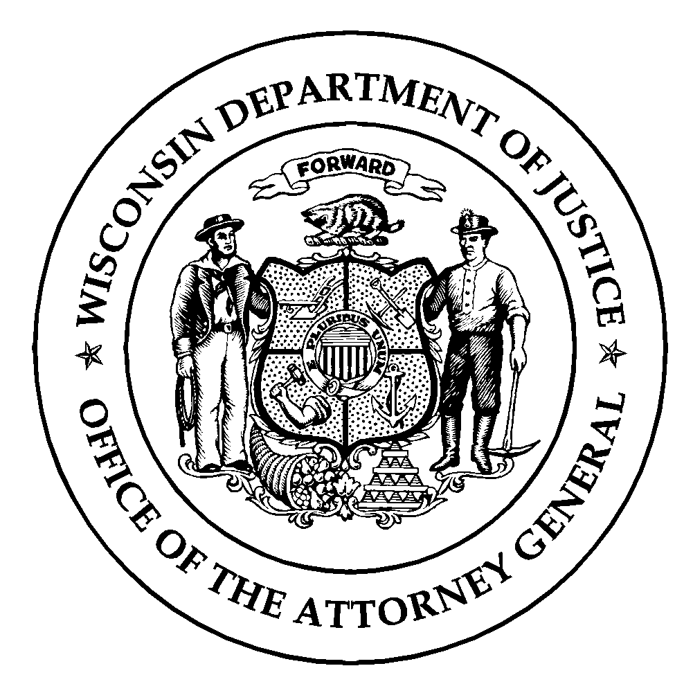Wisconsin Department of Justice
Law Enforcement Standards Board
DJ-LE-310, Rev. 03/2017
https://wilenet.widoj.gov/

STUDENT AUTHORIZATION FOR RELEASE OF INFORMATION
(For official use only, not to be released to unauthorized persons)

I, __________________________________________________________________, authorize
(Student Name)

__________________________________________________________________, (referred to
(Training School Name)

hereafter as “the Training School”) to release to the Wisconsin Department of Justice, Training and Standards Bureau and/or its employees (collectively referred to hereafter as “the Bureau”) any and all academic records or information in the possession of the Training School (technical college or employer-based academy) related to my attendance, performance, achievement and all other aspects of my participation in any training courses and/or programs including, but not limited to, the academic records listed on the reverse side of this form, for the purpose of validating that the Training School and its students meet eligibility and certification standards established by the State of Wisconsin Law Enforcement Standards Board.

I also authorize the Bureau to disclose any or all of the information described in the preceding paragraph to any training school certified by the Law Enforcement Standards Board. Furthermore, in the event that I am employed by or have applied for employment with one or more law enforcement, jail and/or secure juvenile detention employers, I authorize the training school and/or the Bureau to disclose any or all of the information described in the preceding paragraph to such employers. I understand that this authorization will remain in effect until I rescind it by submitting a letter to the director of the Bureau and the director of the Training School specifying that I no longer wish to authorize access to my academic records or information.

Date Signature - Full Name

minimum Academic Records Maintained on
students in preparatory law enforcement, jail and
secure Juvenile detention officer training programs, and students in instructor development and topic specific instructor courses

- Student rosters including enrolled student names and social security numbers.
- Attendance records.
- Student withdrawal/termination from training.
- Any incomplete or failed program.
- Documentation of any disciplinary or other problems and sanctions imposed.
- Staff evaluations of student performance.
- Disability accommodation requests and approval documentation.
- Exams and examination results, including scenarios and scenario evaluation results.
- Performance assessment tasks and performance assessment task results.
- Completed skills competency checklists for specific skills subjects.
- Board-approved student transcripts (DJ-LE-302, DJ-LE-307, DJ-LE-308, and DJ-LE-309).
- Signed copy of the Law Enforcement Code of Ethics or Jail Officer Code of Ethics.
- Signed form attesting that the school’s written rules, penalties and grievance procedures have been distributed, read and understood.
- Signed form attesting that the school’s grading policy has been distributed, read and understood.
- Verification of a valid driver’s license.
- Completed copy of the Application for Enrollment in Basic Law Enforcement, Jail and/or Secure Juvenile Detention Officer Training (DJ-LE-327).
- Record of oral interview, including questions asked, notes taken by interviewers, and applicant responses.
- Results of criminal history records check.
- Completed Physician’s Assessment form (DJ-LE-332), providing authorization by a licensed physician, physician assistant, or nurse practitioner for student participation in preparatory training.
- Verification that the student has a general educational development diploma or is a high school graduate who has completed a secondary education program through a public school, private school, an equivalency diploma program, or home education program within the United States or its territories.
- Official college transcript showing attainment of at least 60 fully-accredited associate degree level college credits or higher.
- Completed copy of the Birth Certificate Verification form (DJ-LE-322), or a certified copy of the student’s birth certificate.
- Completed copy of the Criminal Justice/Corrections Associate Degree Certification Track Student Declaration form (DJ-LE-328).
- Completed copy of the Criminal Justice/Law Enforcement Associate Degree Certification Track Student Declaration form (DJ-LE-329).
- Completed copy of the 32-hour Criminal Justice Instructor Development Course Application form (DJ-LE-335), and all additional documents requested on the form for admittance into the Criminal Justice Instructor Development Course (CJ-IDC).
- Completed copy of the Instructor Training Course Application form for LESB-Approved Topic Specific Instructor Courses (DJ-LE-336), and all additional documents requested on the form for admittance into a topic-specific instructor course.

