Overview
In order for Portal and TRAIN to function properly, they need to run in Internet Explorer (IE). Microsoft has replaced Internet Explorer with Edge and no longer supports IE. This guide shows you how to change settings in Edge to enable IE mode so that TRAIN and Portal functions properly. NOTE: This setting expires automatically after 30 days. You will need to repeat these steps every 30 days.

Set Edge to Internet Explorer Mode
- Open Edge  - Click the … button on the far right of the tool bar  - Click Settings | 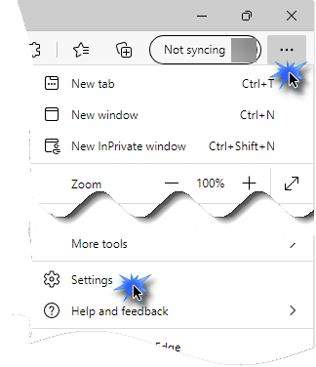
- Click Default Browser in the left navigation bar | 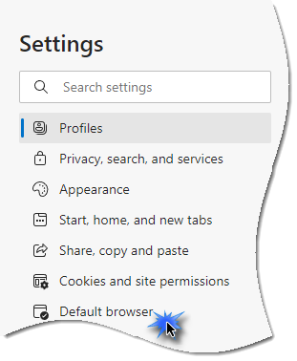
- Click the drop-down arrow for Allow sites to be reloaded in Internet Explorer mode | 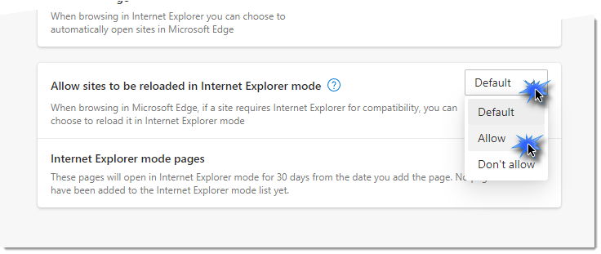
- Click Add next to Internet Explorer mode pages | 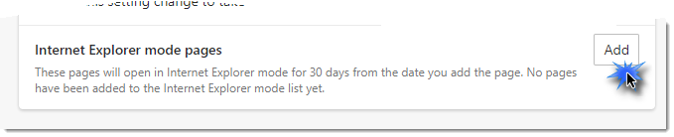  TRAIN- https://ealogin.justice.wisconsin.gov/
- Copy the URL to the right  - Paste the copied URL in the text field  - Click Add | Portal- https://dojportal.justice.wisconsin.gov/Portal%20100/Userlogon.asp  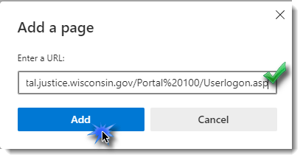
- Click Restart to apply these settings | 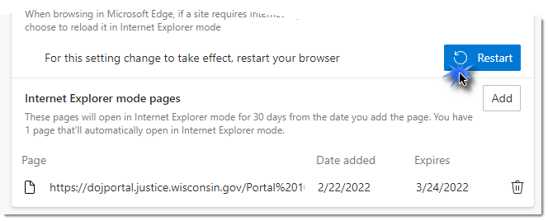
NOTE: This setting expires automatically after 30 days. You will need to repeat these steps every 30 days.

Access Portal and TRAIN and Enable Pop-ups
Edge has a built-in pop-up blocker which may interfere with the logout process and other messages from Portal and TRAIN. It is important to always allow pop-ups and redirects. To allow pop-ups and redirects:
- After successfully logging into Portal or TRAIN, try to log out using the log off menu option on the left side of the screen  - Click the pop-up blocker icon on the far right of the address bar  - Choose Always allow pop-ups and redirects from…  - Click Done | 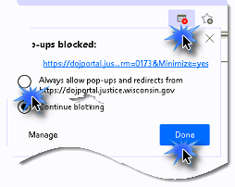

Set Browser Cache to clear at browser close
Because TRAIN and Portal use temporary memory folders to store information, it is recommended to set your browser to clear the cache of all temporary files each time you close the browser so that you start fresh with maximum memory capability. This is especially pertinent with TRAIN as some of the training modules use a large amount of cache to work and operate correctly. To set you browser to clear on exit:
- In the Edge browser, go to the options menu in the top right corner and click on it (three dots).
- In the drop-down menu click on the Settings option.
- Go to the Privacy, Search, and Services section and then go to the Clear Browsing Data section.
- Click on the arrow in the “Choose what to clear every time you close the browser” line and it will then open the options list.
  - Turn on the Browsing History, Download History, Cached images and files. If using eTIME on that workstation, then they will also need to turn on the Autofill form data as that is not allowed per CJIS if using an application that accesses NCIC data.
- Go back to the previous tab and do this for the Clear browsing data in Internet Explorer as well by making sure the “Clear Chosen Data for IE and IE Mode every time you exit Microsoft Edge” option is turned on.

