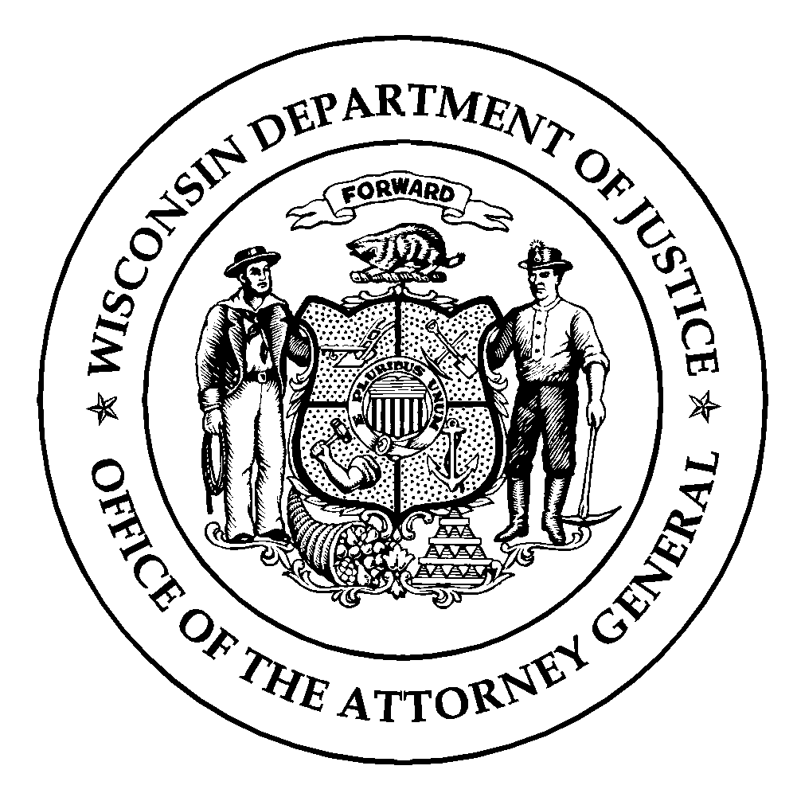Wisconsin Department of Justice
Law Enforcement Standards Board
DJ-LE-300, Rev. 12/2021
https://wilenet.widoj.gov/

AUTHORIZATION FOR RELEASE OF INFORMATION

I hereby authorize the Wisconsin Department of Justice, Training and Standards Bureau, which staffs the Wisconsin Law Enforcement Standards Board (Wis. Stat. § 165.86(1)(a)), to obtain verification of my training, certification/licensure and employment as a law enforcement officer from the Police Officer Standards and Training (POST) Agency from which I obtained my law enforcement certification/license. I also authorize access to any disciplinary actions taken against my law enforcement certification/license and access to my law enforcement employment records in order to verify that I left prior law enforcement employment voluntarily with a good record.
Name of Applicant:
Last First Middle

Date of Birth:
Month / Day / Year

Last 4 Digits of SSN:

Applicant’s Signature Date

This Authorization for Release of Information form must be signed and returned in order for you to be considered for participation in the Law Enforcement Reciprocity Examination.

Mail to:
Training and Standards Bureau
P.O. Box 7070
Madison, WI 53707-7070

