Overview
In order for Portal and TRAIN to function properly, they need to run in Internet Explorer (IE). Microsoft has replaced Internet Explorer with Edge and no longer supports IE. This guide shows you how to change settings in Edge to enable IE mode so that TRAIN and Portal functions properly. NOTE: This setting expires automatically after 30 days. You will need to repeat these steps every 30 days.

Set Edge to Internet Explorer Mode
- Open Edge  - Click the … button on the far right of the tool bar  - Click Settings | 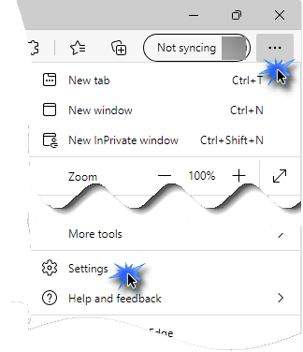
- Click Default Browser in the left navigation bar | 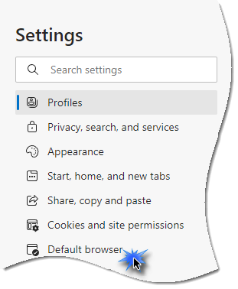
- Click the drop-down arrow for Allow sites to be reloaded in Internet Explorer mode | 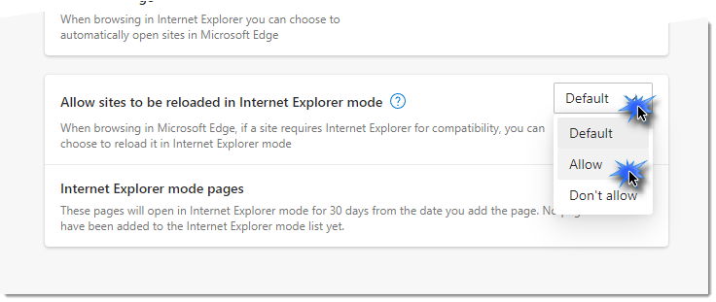
- Click Add next to Internet Explorer mode pages | 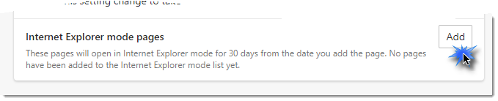  TRAIN- https://ealogin.justice.wisconsin.gov/
- Copy the URL to the right  - Paste the copied URL in the text field  - Click Add | Portal- https://dojportal.justice.wisconsin.gov/Portal%20100/Userlogon.asp  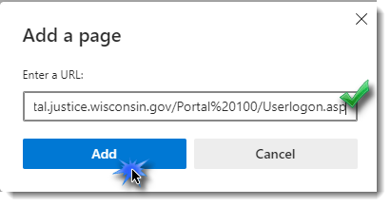
- Click Restart to apply these settings | 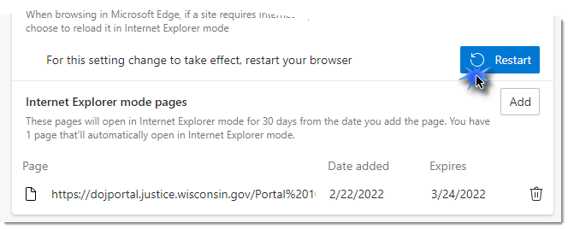
NOTE: This setting expires automatically after 30 days. You will need to repeat these steps every 30 days.

Access Portal and TRAIN and Enable Pop-ups
Edge has a built-in pop-up blocker which may interfere with the logout process and other messages from Portal and TRAIN. It is important to always allow pop-ups and redirects. To allow pop-ups and redirects:
- After successfully logging into Portal or TRAIN, try to log out using the log off menu option on the left side of the screen  - Click the pop-up blocker icon on the far right of the address bar  - Choose Always allow pop-ups and redirects from…  - Click Done | 