**[](https://wilenet.org/html/career/index.html)**

***PHYSICAL READINESS TESTING HANDBOOK***

**December 2020**

**(Revised)**

# 

The purpose of this Handbook is to provide the necessary guidance and details for conducting physical readiness testing of law enforcement officers: applicants, recruits, and incumbents. There are six sections:

* Test Day Procedures
* Testing Sequence
* Physical Readiness Test Standards
* Physical Readiness Test Procedures
* Exercise Preparticipation Health Screening Questionnaire
* Score Sheet

**TEST DAY PROCEDURES**

Reporting time and the test site will be determined and posted. Participants will be cleared prior to testing or will be provided with a PAR-Q or similar pre-participation screening tool; the results will help determine whether it is safe for them to complete the fitness testing. **All scripts are bolded and in “quotation marks.”** At the start of the testing, brief all participants by reading the following script:

**Initial Briefing**

**”Today, you will complete a battery of physical readiness tests. The fitness tests measure the factors that underlie the ability to perform the essential and critical physical tasks required of you. It is important that you give a good effort. Pace yourself. You will perform a vertical jump, agility run, sit ups, 300 meter run, push ups, and a 1.5 mile run. *(If the either of the optional tests, the bench press or the sit and reach will be conducted, indicate they will take place at the end.)* If at any time you don’t feel well, tell one of the staff. Do you have any questions?”**

**Physical Readiness Tests**

The test procedures are scripted to ensure reliability of test administration. **All scripts are bolded and in “quotation marks.”** Assign one exercise physiologist or fitness coordinator to lead a group warm up. Allow an additional two minutes for individual warm up.

**TESTING SEQUENCE**

Candidates/officers will complete the fitness test battery in the same order. For convenience, you may brief and demonstrate the first two tests (Vertical Jump and Agility Run), then cycle the group through those tests. The last four fitness tests will be completed as a group.

*It should be noted here: the locations and times listed below are intended to be minimum guidelines only and are not intended to dictate or to interfere with the business necessity of testing for the Training and Standards Bureau, the Law Enforcement Standards Board, academies or employing agencies. If testing of large groups is required, for instance, the size of the group will impact rest intervals. To ensure consistency, Candidates/officers should be organized, by number, prior to testing and should complete the test items/battery in the order so established, throughout the test session.*

***Please note the bench press and the sit and reach tests are optional. If either or both is used, the test(s) should be conducted at the end of the test sequence or at a different time to avoid adversely impacting the performance on the required tests.***

Sequence for Fitness Tests

PLACE TIME EVENT

Inside 5 minutes 1. Briefing

Inside or 10 minutes 2. Warm up

Outside 3. Vertical jump

4. Illinois Agility Run

Briefing on test

5. Sit up

Briefing on test

Outside 6. 300 meter run

5 minutes Rest and briefing on test

Inside or 7. Push up

Outside

30 minutes Rest and briefing on tests

8. Warm up

Outside 9. 1.5 mile run

10. Cool down

11. Stretch and hydrate to recover

**PHYSICAL READINESS TEST STANDARDS**

The physical readiness test battery has validity evidence to support its use as a job-related requirement for selection, training, and retention of law enforcement officers in the State of Wisconsin. The standards represent the level of physical fitness which predicts safe and effective job performance of the essential physical tasks required of police. The standards are presented in the table below.

|  |  |  |  |  |  |  |
| --- | --- | --- | --- | --- | --- | --- |
|  | **Vertical**  **Jump**  **(inches)** | **Agility**  **Run**  **(sec)** | **Sit**  **Ups**  **(count)** | **300**  **Meter**  **Run**  **(sec)** | **Push**  **Ups**  **(count)** | **1.5 Mile**  **Run**  **(min:sec)** |
| **Entrance**  **Standards** | **11.5** | **23.4** | **24** | **82** | **18** | **20:20** |
| **Exit**  **Standards** | **14.0** | **19.5** | **30** | **68** | **23** | **16:57** |

The test battery is the same for each sworn classification in the department; the standards differ. Therefore, the scripts and testing procedure are the same. Particular attention should be paid to the scripts to ensure the proper standards are articulated during the in-brief process.

**PHYSICAL READINESS TEST PROCEDURES**

## Vertical jump

**“The first event is the vertical jump, a measure of total body explosive power. It is an important area for pursuit tasks that require jumping and vaulting.”**

****“Watch this demonstration. Stand under the test apparatus, and reach up as high as you can with one arm while placing your bicep next to your ear. The apparatus will be lowered to your fingertips. Take one step back with either foot.  Then step forward, and jump, reaching as high as possible, and hit the tabs. Or you may jump from both feet without taking a step.  Your score is the highest tab you reach, and will be recorded to the half-inch. You will have three attempts for this event.”****

****“The entrance standard for the vertical jump is 11.5 inches. Are there any questions?”****

****“The exit standard for the vertical jump Is 14 inches. Are there any questions?”****

Instructor tips:

As each participant approaches the area for the VJ, take her/his score sheet. . Record each attempt, and enter the best score as the participant’s score for the VJ **OR** indicate a pass/fail score as indicated.

Equipment

* Vertec

Procedural tasks

a) Participant stands under the apparatus and reaches up as high as possible to mark his/her standing reach.

b) Coordinator adjusts the stack of tabs to a point immediately above the tips of the fingers. (Figure 1)

c) Participant steps back with either foot (Figure 2), steps forward then jumps as high as possible and strikes the tabs OR the participant may jump with both feet (Figure 3) and not take a step.

d) Score is the inches jumped to the nearest ½ inch. (Figure 4)

e) The best of three (3) trials is the score **OR** it may be a pass/fail.

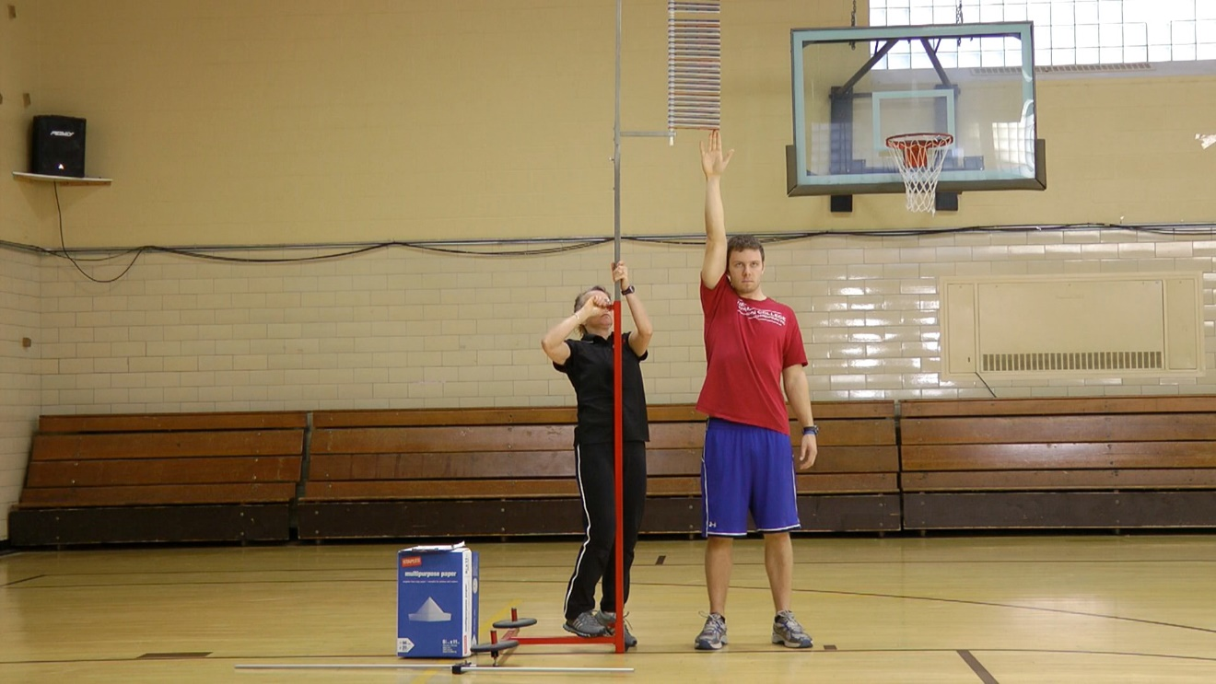

Figure 1

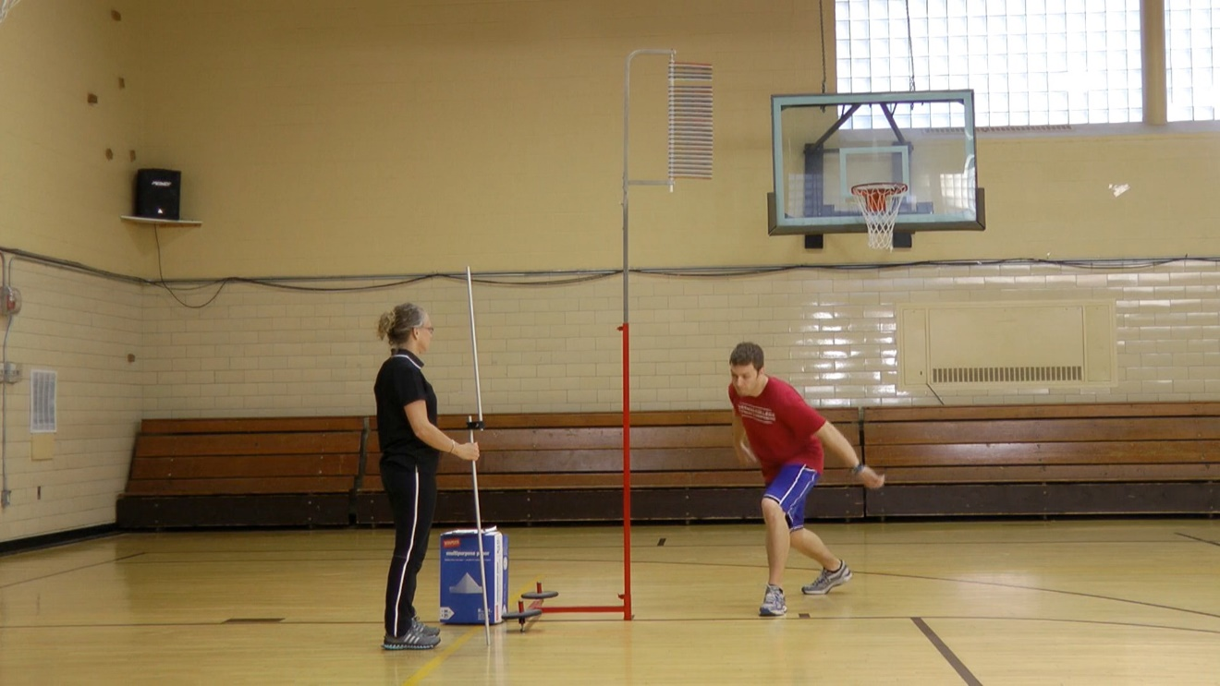

Figure 2

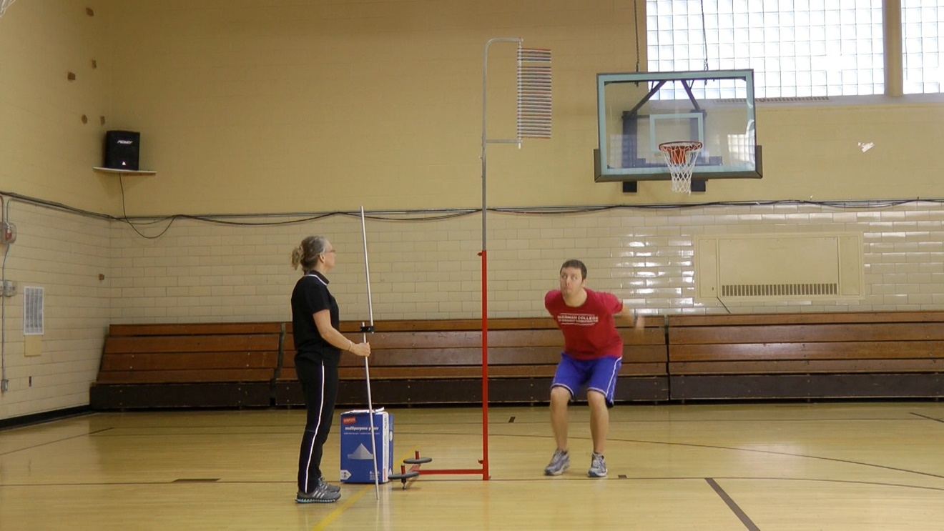

Figure 3

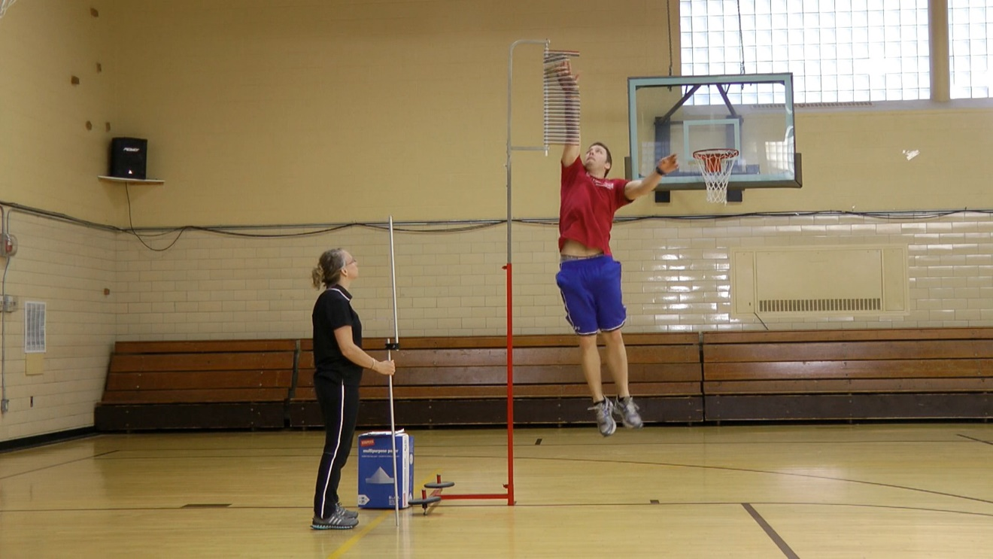

Figure 4

**Illinois agility run**

“The second event is the Illinois agility run, a measure of coordinated movement and speed. It is an important area for performing tasks requiring quick movements around obstacles.”

“Watch this demonstration. Start in the prone position to the left of the first cone with the tips of your fingers behind the starting line. When the instructor says, “GO”, stand up and sprint to the forward line (point to line 30 feet away), place one foot over the line, and sprint back to the starting line. Make a left turn around the first cone, then zig-zag in a figure eight fashion around the four cones and zig-zag back to the start line. Turn left around the first cone, and sprint to the forward line and back one more time. The clock stops when any part of your body crosses the finish line. If you knock over a cone, miss a turn, or fail to cross the line when turning, the instructor will stop you and return you to end of the line for a restart. Your score is the time it takes to complete the run, and will be recorded to the tenth of a second. You will have two trials for this event.”

“The entrance standard for this event is 23.4 seconds. Are there any questions?”

“The exit standard for this event is 19.5 seconds. Are there any questions?”

Instructor tips:

Allow a five minute warm up prior to the agility run. As the participant approaches the test area, take her/his score sheet, and record the score **OR** pass/fail result, upon completion. The starting position is on the left side of the first cone. Start the clock upon the command “Go.”

Equipment

* Marked course of 30 feet, with four cones spaced 10 feet apart in a line (Figure 5)
* Stop watch

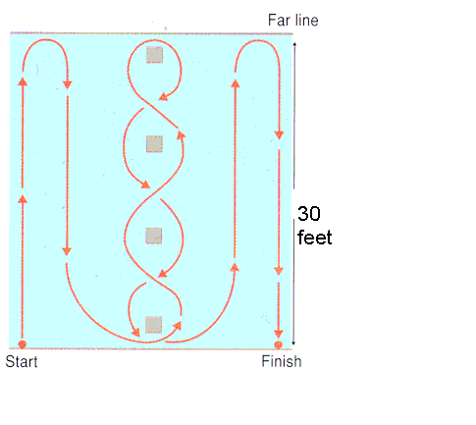

Figure 5

Procedural tasks

a) Participant lies on the ground with fingertips behind the start line. (Figure 6)

b) At the "GO" start, participant gets up, sprints to the other line (30 feet away) places one foot over the line then sprints back to the start line.

c) Participant makes left turn around the first cone then zig zags in a figure eight fashion around the four cones and back to the start line. (Figure 10)

d) Participant then sprints up and back as described in (b).

e) Record finish time in seconds and tenths.

f) Allow one slow walk through and two (2) trials. Score is the best (lowest) time **OR** it may be a pass/fail.

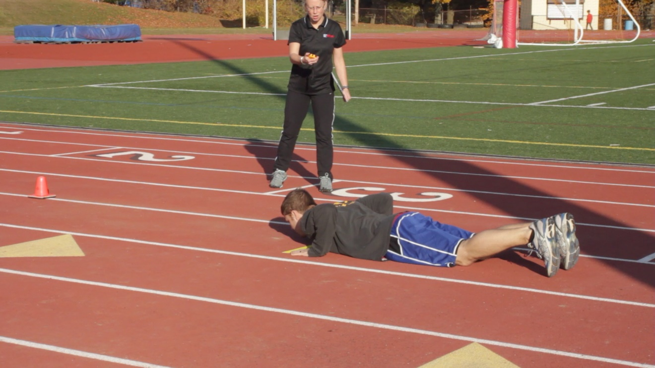

Figure 6

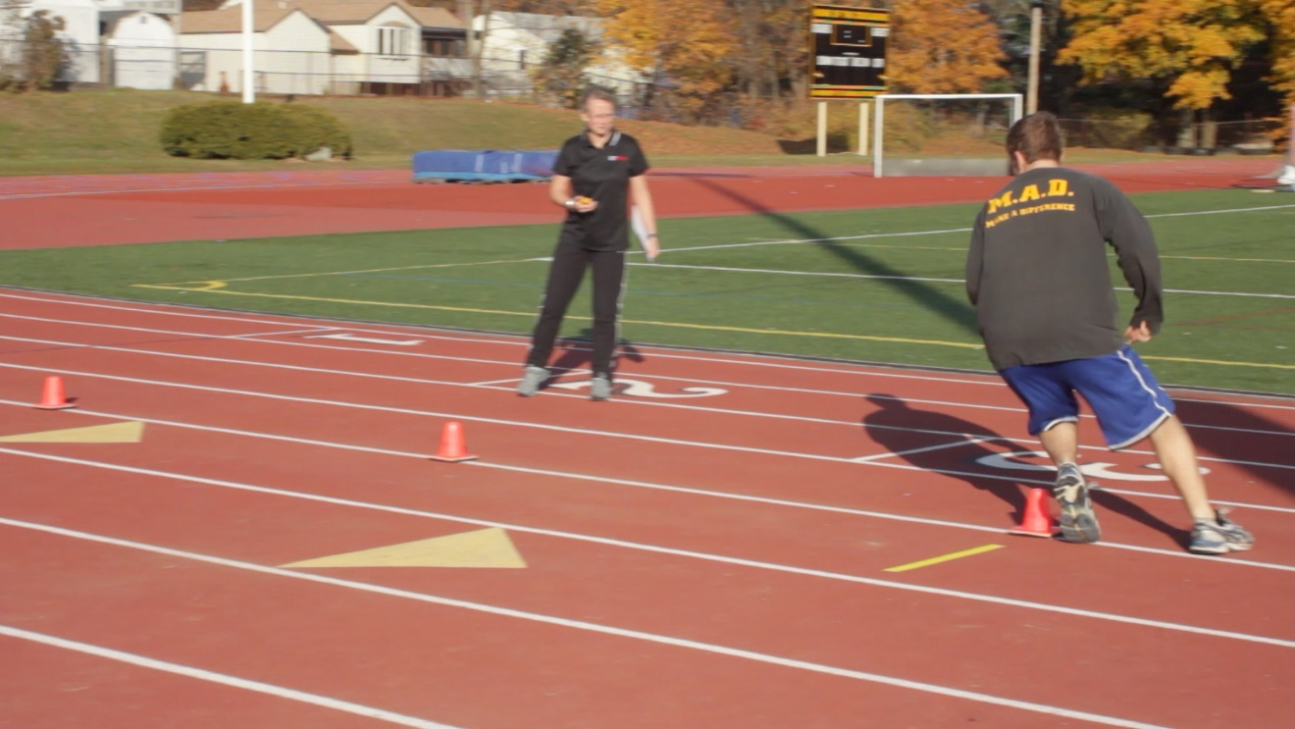

Figure 7

**One-minute Sit-up Test**

**“The third event is the one-minute sit up, which measures muscular endurance of the abdominal muscles, an important area for many physical tasks and injury prevention.”**

“Watch this demonstration. Lie on your back, with your knees bent at approximately a 90 degree angle. Your feet may be together or apart, but the heels must stay in contact with the surface. Your partner will hold your ankles. The tips of your fingers must stay behind the ears. When I say “GO,” lift your upper body (head and torso) by bending at the waist, move your elbows to or past your kneecaps. Return to the starting position, with your shoulder blades touching the surface. That will constitute one repetition. If you arch your back, lift your buttocks from the mat, move your finger tips forward of your ears, fail to touch the kneecaps, stop to rest in the down position, or fail to touch your shoulder-blades to the mat, you will receive a warning. For any subsequent violation, the repetition will not count. You may rest momentarily in the up position during the test but every effort should be made to move continuously throughout the test period. You will have one minute to complete the proscribed number of sit ups. I will announce 45, 30, 15 seconds, and count out the last ten seconds. Your score is the number of proper form sit-ups performed. “

“The entrance standard for this event is 24 correct sit ups. Are there any questions?”

“The exit standard for this event is 30 correct sit ups. Are there any questions?”

Instructor tips:

Have a demonstrator execute several correct sit-ups while you are reading the directions. Repeat the demo after finishing the instructions. During the second demo, point out common errors. Divide the participants into as many groups as there are coordinators. Coordinators will position themselves at a 45 degree angle to the left front of the participant being tested. From that position you should be able to observe that the elbows touch or extend pass the knees, fingers remain behind the ears, the shoulders touch the mat, the heels remain in contact with the floor, and that the buttocks remain on the mat.

Equipment:

* Mat
* Stopwatch

Procedural tasks:

a) The participant starts by lying on his/her back, knees bent, and heels flat on the floor. Finger tips stay behind the ears. (Figure 8)

b) A partner holds the feet down.

c) The participant then performs as many correct sit-ups as possible in one minute.

d) In the up position, the participant must touch or extend past the kneecaps with the elbows, then return the shoulders to the ground before starting the next sit up. The participant may rest momentarily in the ‘up’ position. (Figure 9)

e) The participant cannot raise the buttocks from the ground and when returning to the down position the shoulder blades must touch the ground.

f) Score is total number of correct sit-ups in 1 minute **OR** it may be a pass/fail.

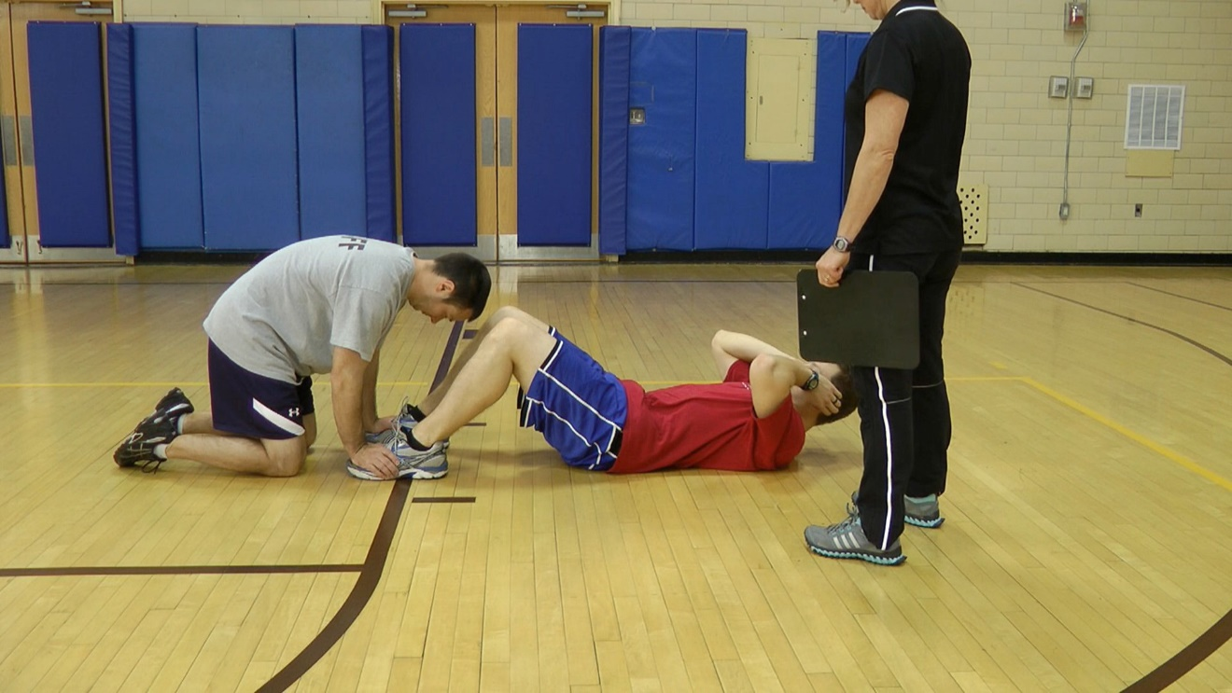

Figure 8

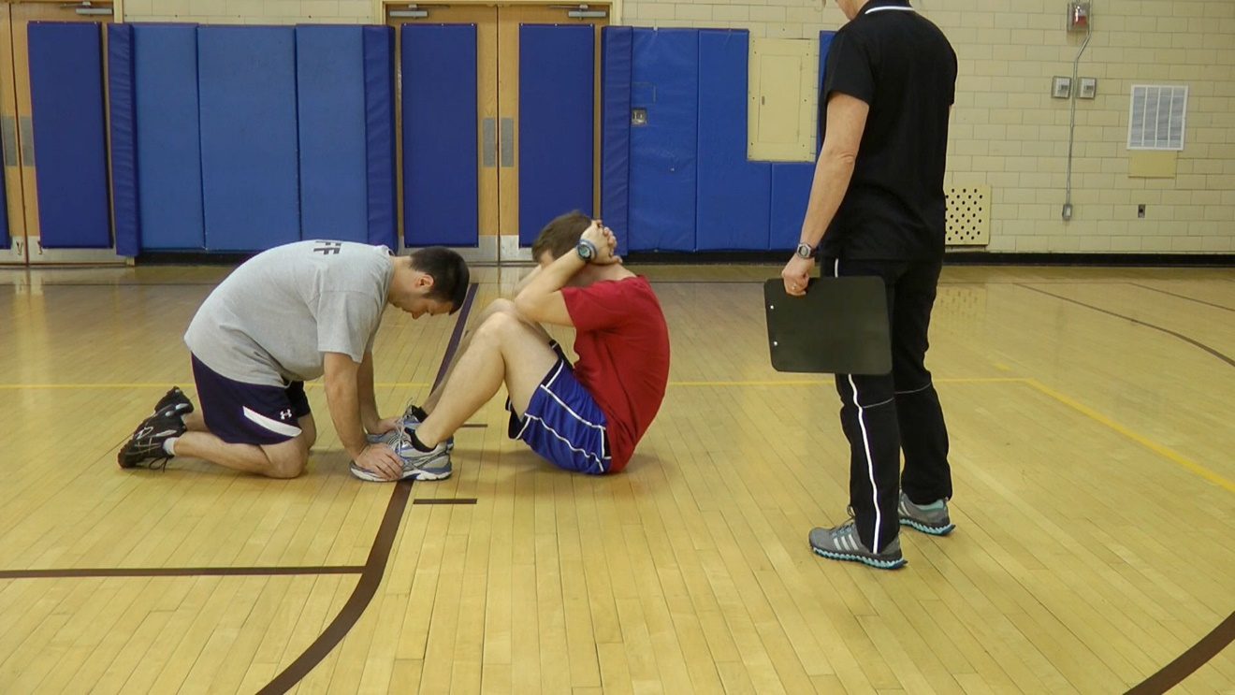

Figure 9

**300 meter run**

**“The fourth test is the 300 meter run, a test of anaerobic capacity. This is an important area for performing short intense burst of effort such as in pursuit tasks. The score is the time it takes to complete the course. (Explain the course/track)”**

**“You will start here (point out starting line) and at the command “GO” run as fast as possible to the finish line here. You must complete the run without help.”**

**“The entrance standard for this event is 82 seconds or less. Are there any questions?”**

**“The exit standard for this event is 68 seconds or less. Are there any questions?”**

Instructor tips:

Allow a five-minute warm up. For each group, start as many participants as there are coordinators. Each coordinator will record the time for one participant OR indicate pass/fail.

Equipment:

* Marked course of 300 meters (984 ft.) (Figure 10) For safety and standardization purposes, the course must be measured with a properly functioning distance measuring device such as wheel. The figure is for use on a standard track. Other testing courses may be used but it is recommended that every effort be made to ensure safety and consistency to include a flat terrain.
* Stop watch

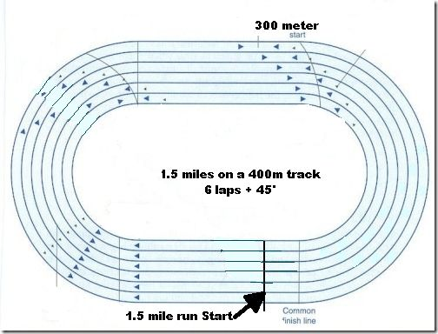

Figure 10

Procedural tasks:

a) Allow five minutes to warm up.

b) At "GO" participant runs the 300 meter course as fast as possible.

c) Record the time it takes to complete the course **OR** indicate a pass/fail.

**Push-up Test**

**“The fifth event is the push-up, a measure of the muscular endurance of the upper body (chest, shoulders, and triceps). This is an important area for many tasks including use of force, lifting, carrying, and pushing.”**

“Watch this demonstration. Assume the front-leaning rest position by placing your hands on the surface, slightly wider than shoulder width apart, fingers facing forward. The back, buttocks, and legs must be in a generally straight line from the head to the heels. The feet may be together or up to twelve inches apart. When the instructor says “GO,” lower your body by bending the elbows until the tops of the upper arms, shoulders, and upper back are aligned and parallel to the ground. Return to the starting position by soft-locking your elbows. This constitutes one repetition. You may rest momentarily in the up position but every effort should be made to move continuously throughout the test period. You must keep your body straight from your heels to your shoulders and soft-lock your elbows or you will receive a warning. For any subsequent violation, the repetition will not count. The test will be considered over when the participant returns to a standing position or if one or both knees make contact with the ground. There is no time limit. Your score is the number of correct push-ups. *Prior to beginning your test, you will perform a correct push up for the Coordinator counting for you to ensure proper technique.”*

“The entrance standard for this event is 18 correct push ups. Are there any questions?”

*“*The exit standard for this event is 23 correct push ups. Are there any questions?”

Instructor tips:

Have a demonstrator execute several correct push-ups while you are reading the directions. Repeat the demo after finishing the instructions. During the second demo, point out common errors. Lightly touch the back of the elbow to ensure they are locking out. Coordinators should position themselves at a 45 degree angle to the left front of the participant being tested. From that position you should be able to observe that the body remains in a generally straight line, the shoulders are parallel to the ground in the down position, and the elbow locks out upon return the starting position.

Procedural tasks:

a) The participant starts in the front leaning rest position. Hands are slightly more than shoulder width apart; feet are 12" apart or less (Figure 11)

b) The participant lowers self until the upper arms are parallel to the ground, then pushes up again. (Figure 12)

1. The back must be kept straight throughout the exercise.
2. There is no time limit. The score is the correct number of push ups **OR** pass/fail.

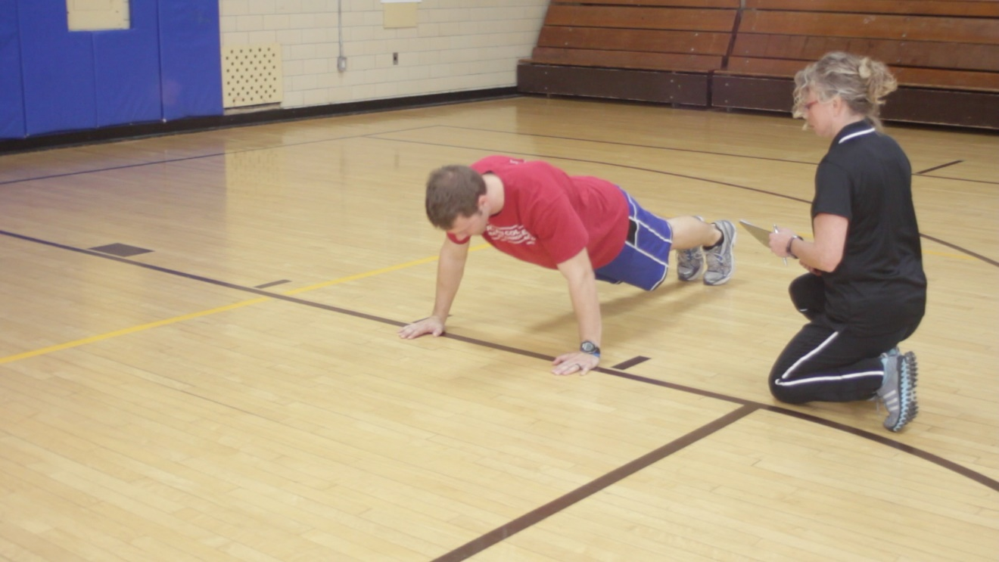

Figure 11

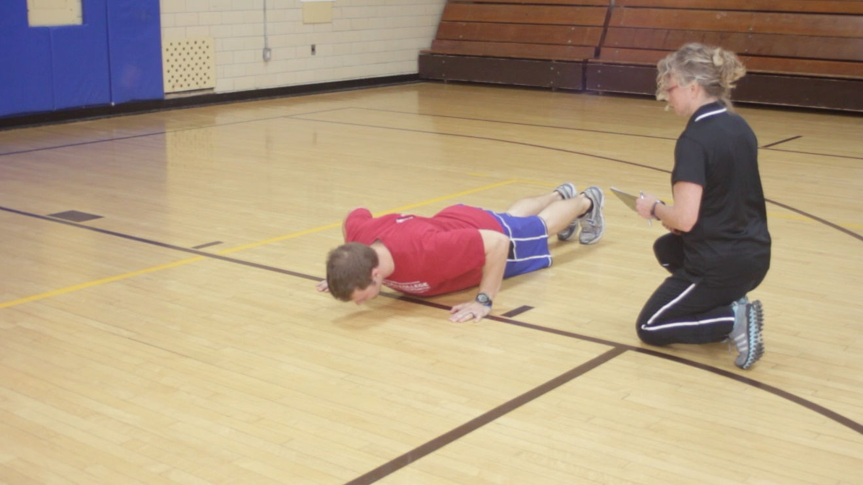

Figure 12

**1.5 Mile run**

**“The final event is the 1.5 mile run, a measure of cardiovascular endurance or aerobic capacity. This area is important for running pursuits and use of force situations lasting more than two minutes.**

**“You will line up behind the starting line. At the command “GO” start running . (Explain the course/track) Your goal is to complete the 1.5 miles in as fast a time as you can. As you complete each lap your time and number of laps to go will be announced. You may walk, but try to keep running for the entire distance. You may run alongside another runner for help with the pace, but you may not physically assist or be assisted by another runner. After the run do not sit down or stand still but walk slowly for a lap.”**

**“The entrance standard for this event is 20 minutes and 20 seconds or less. Are there any questions?”**

**“The exit standard for this event is 16 minutes and 57 seconds or less. Are there any questions?”**

Instructor tips:

Have a monitor on the other side of the track. Divide the group evenly amongst the coordinators, who will record times for each participant in their group. If no numbers are available, have each person call out their name as they complete each lap.

Equipment:

* Marked level course (See Figure 13) For safety and standardization purposes, the course must be measured with a properly functioning distance measuring device such as wheel. The figure is for use on a standard track. Other testing courses may be used but it is recommended that every effort be made to ensure safety and consistency to include a flat terrain.
* Stop watch
* Numbered vests if available

Procedural tasks:

a) Have participants warm up.

b) Participants should be instructed to cover the distance as fast as

possible.

c) At the command "GO" time is started.

d) Score is time (min:sec) to run the course **OR** pass/fail.

e) A cool down is required after running.

**Optional tests**

**Bench press**

**Bench Press (For maximum testing)**

**“The bench press test measures the amount of weight pushed from the bench press position. It measures the amount of force the upper body can generate. It is an important area for performing tasks requiring upper body strength such as use of force situations.”**

“Lie on the bench with your feet flat on the floor. If your feet do not reach the floor, use these plates – (*plates will be identified by the instructor*). Be sure your back is flat against the bench. With a positive grip (thumbs around the bar), use the markings on the bar to evenly spread your hands from the center of the bar. You will first warm up by performing 3 to 5 repetitions with a light weight. If you don’t know how much weight you should warm up with, we suggest you press the bar or up to approximately half of your body weight. (*Have the demonstrator press a sub-max weight five or six times*) After the warm up, you will be given successively heavier weights until you reach your best effort. Watch this demonstration. You may receive a ‘lift off’ or you may remove the bar from the uprights by yourself. Lower the bar until it is just touching your chest and hold it in this position. The instructor will say, “Ready, lift.” (This will be conducted on a 1-2 cadence.) On the command “Lift,” push the weight up to arms length exhaling as you perform the movement. The spotters will not touch the bar if it stalls on the way up; they will take the weight if the bar begins to move downward or if you ask them to take it from you. You should reach your best effort in approximately five attempts. If you know your best effort, you may attempt that weight after the warm up, but everyone must complete the warm up to lower the chance of injury. Are there any questions?”

**Bench Press (For standard testing)**

**“The bench press test measures the amount of weight pushed from the bench press position. It measures the amount of force the upper body can generate. It is an important area for performing tasks requiring upper body strength such as use of force situations.”**

“Lie on the bench with your feet flat on the floor. If your feet do not reach the floor, use these plates – (*plates will be identified by the instructor*). Be sure your back is flat against the bench. With a positive grip (thumbs around the bar), use the markings on the bar to evenly spread your hands from the center of the bar. You will first warm up by performing 3 to 5 repetitions with a light weight. If you don’t know how much weight you should warm up with, we suggest you press the bar and up to approximately half of your body weight. (*Have the demonstrator press a sub-max weight five or six times*) After the warm up, you will be given successively heavier weights until you reach your standard. Watch this demonstration. You may receive a ‘lift off’ or you may remove the bar from the uprights by yourself. Lower the bar until it is just touching your chest and hold it in this position. The instructor will say, “Ready, lift.” (This will be conducted on a 1-2 cadence.) On the command “Lift,” push the weight up to arms length exhaling as you perform the movement. The spotters will not touch the bar if it stalls on the way up; they will take the weight if the bar begins to move downward or if you ask them to take it from you. You should reach your standard in approximately five attempts. Everyone must complete the warm up to lower the chance of injury.”

“The recommended standard for this event is to press 83% of your current body. That weight will be calculated and rounded down to the nearest five- pound increment. Are there any questions?”

Instructor tips:

Use three spotters. The spotter behind the bar will give all commands, ensure that the lifter has an even grip, and that the weight is evenly loaded on the bar. Increase the weight in ten pound, or larger increments to completion Be careful when helping return the bar to the rack that you don’t get your face in the way. Be sure the participant does not arch their back. If the lifter is experienced and has a pretty good idea of his/her max, allow them to move right to that weight after the warm up if they desire. But everyone must at least do the warm up before attempting their best effort.

Equipment:

* Bench
* Bar and weights

Procedural tasks

1. Use three spotters. (Figure 14)
2. Ask the participant if he/she has any idea how much weight he/she can press one time.

c) If there is an estimated weight, start with about one-half of that estimated weight. If not, a weight between the bar alone – 45 lbs., up to one half of their body weight should be used.

d) The participant performs 3- 5 repetitions with that weight as a warm up.

e) The participant receives a ‘lift off’ by the spotters or may remove the bar from the uprights by him/herself. (Figure 15)

f) The participant lowers the bar until it is just touching their chest and holds it in this position. (Figure 16) The instructor says, “Ready, lift.” (This will be conducted on a 1-2 cadence.) On the command “Lift”, the participant pushes the weight up to arms length exhaling as the movement is performed. (Figure 5)

g) Increase the weight in appropriate increments. Instruct the participant to lift each additional weight increment. The first three to four sets serve as warm-up lifts in order to prevent muscle injury and to prepare the participant for a best effort lift on the fifth or sixth effort.

h) The score for this test is the number of pounds lifted in one repetition.

i) Divide the 1RM score by the participant’s body weight for the BP ratio score.

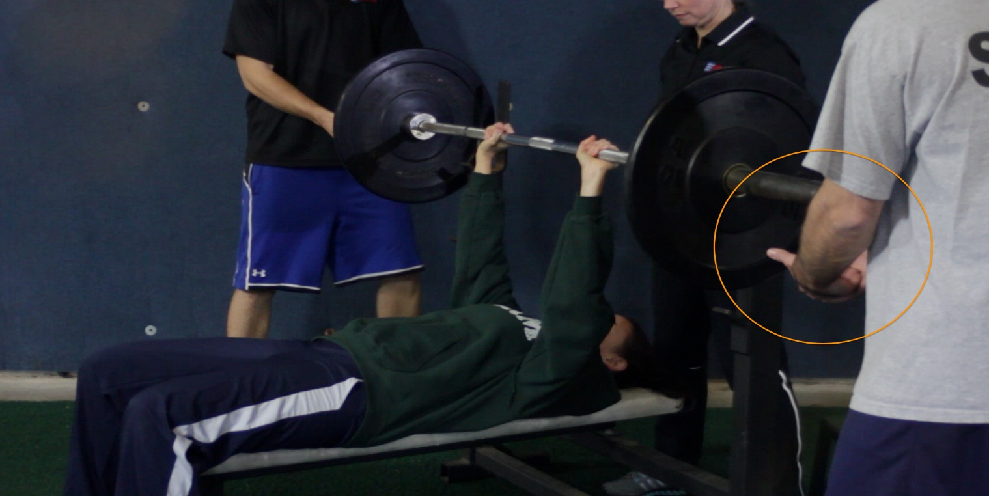

Figure 14

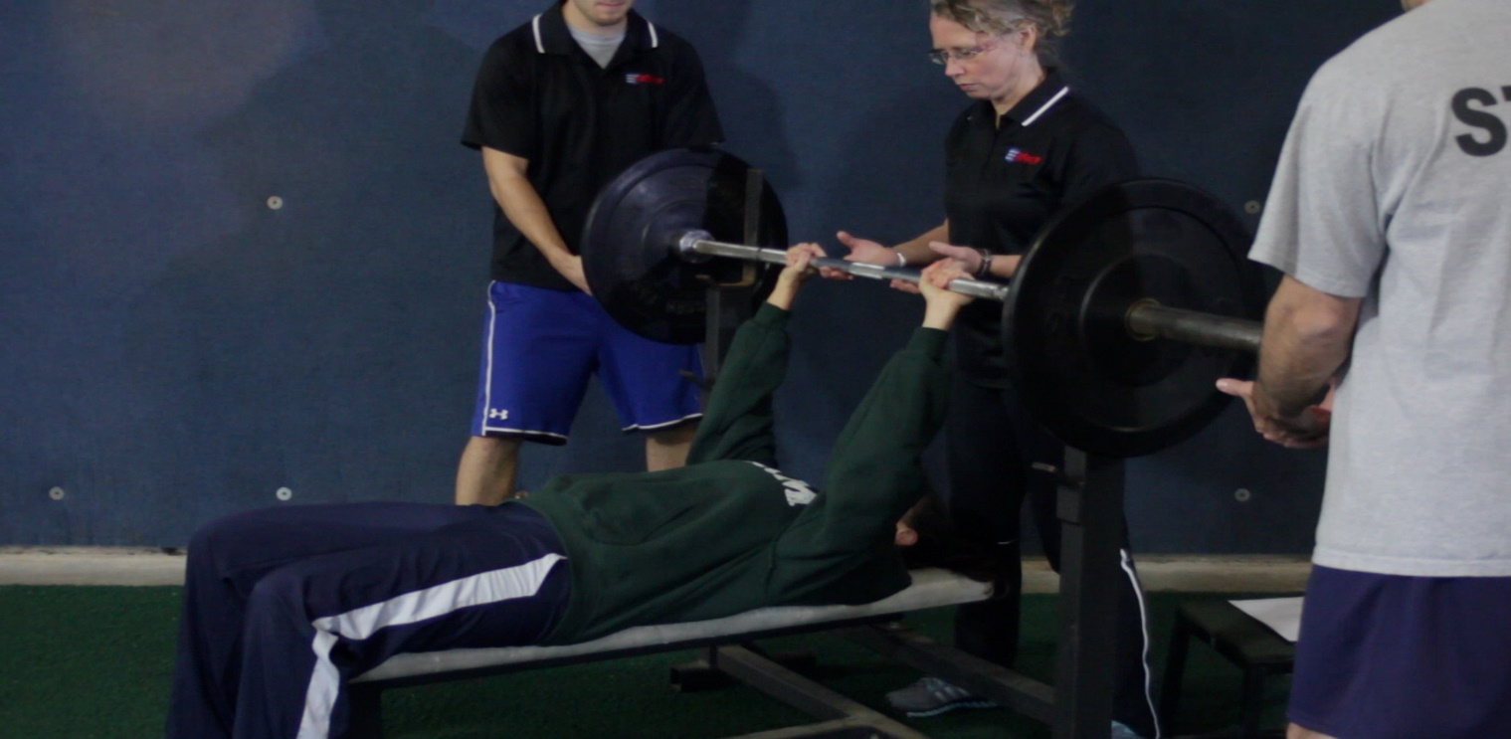

Figure 15

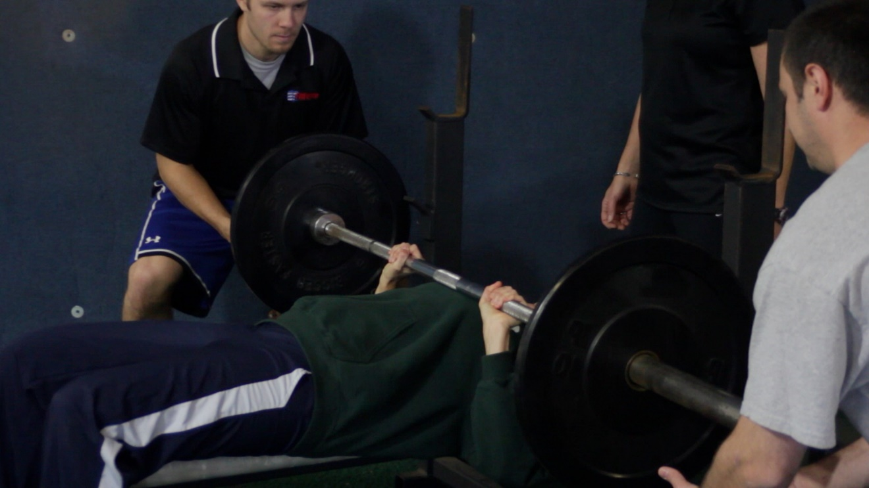

Figure 16

**Sit and reach**

“**The sit and reach is a measure of the static flexibility of the lower back and upper leg area. It is an important area for performing tasks involving range of motion and is important in minimizing lower back problems.”**

**“Watch this demonstration. Sit on the ground with your shoes off. Keep your legs flat on the floor and heels against the box, together or up to eight inches apart. Place one hand over the other, with your middle fingers together. Slowly bend forward at the waist, tuck your head, and reach as far as you can being sure to push the metal slide forward while keeping your fingers in constant contact with the slide at all times. Exhale as you do this. Hold that position for two seconds. You will have three tries at this event, with your best effort to the last half inch counting as your score. Are there any questions?”**

Instructor tips:

Ensure that the knees remain straight throughout the exercise. Touch the knee if necessary as a reminder. Do not allow the participant being tested to bounce forward. The movement should be smooth and continuous. Divide the group evenly among as many sit and reach boxes as are available. Round off the score to the nearest ½ inch.

Equipment:

* Box
* Yardstick on box with 15" mark at edge
* Or a commercially available sit and reach box

Procedural tasks:

a) The participant should warm up slowly by practicing the test.

b) The participant sits on the floor or mat with legs extended at right angles to the box. Shoes are off.

c) The heels touch the near edge of the box and are eight inches apart.

d) A yardstick rests on the box with the 15 inch mark on the near edge of the box.

e) The participant slowly reaches forward with both hands (one on top of the other) as far as possible and holds the position for two seconds.

f) The distance reached on the yardstick by the fingertips to the last half inch is recorded. (Figure 17)

g) The best of three trials is recorded as the flexibility score.

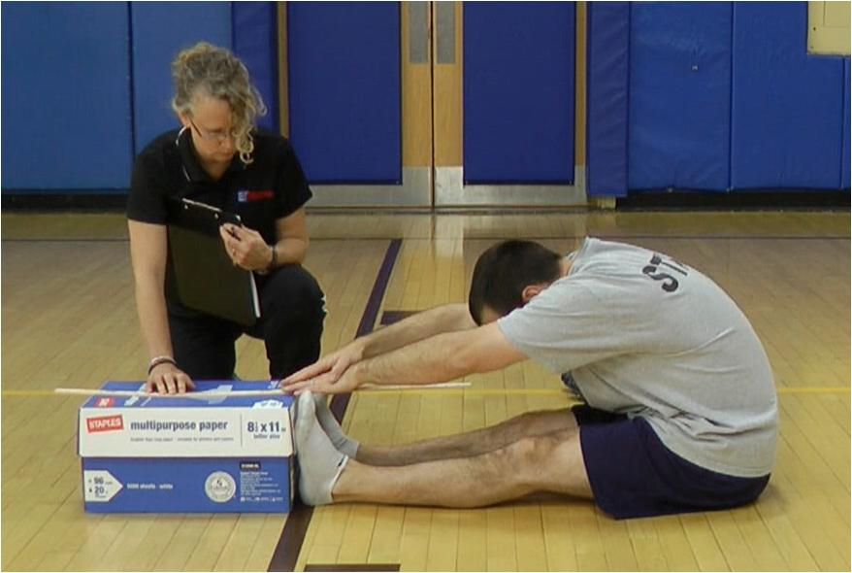

Figure 17

**Exercise Preparticipation Health Screening Questionnaire**

Review the areas below. Mark all ***true*** statements.

**Step 1: Signs and Symptoms**

Do you experience:

* Chest discomfort with exertion
* Unreasonable breathlessness
* Dizziness, fainting, blackouts
* Ankle swelling
* Unpleasant awareness of a forceful, rapid or irregular heart rate
* Burning or cramping sensations in lower legs when walking short distance
* Known heart murmur

If any statements are true, STOP, the applicant/officer should seek medical clearance before engaging in or resuming exercise.

**Step 2: Current Activity**Have you performed planned, structured physical activity for at least 30 minutes at moderate intensity on at least 3 days per week for at least the last 3 months?

* Yes
* No

Continue to Step 3.

**Step 3: Medical Conditions**

Have you in the past or do you currently have:

* A heart attack
* Heart surgery, cardiac catheterization, or coronary angioplasty
* Pacemaker/implantable cardiac defibrillator/rhythm disturbance
* Heart valve disease
* Heart failure
* Heart transplantation
* Congenital heart disease
* Diabetes
* Renal disease

**Instructions:** *To be used with ACSM Preparticipation Health Screening Flowchart.*

* If **there are NO true statements in Step 3**, medical clearance is not necessary
* If **Step 2** is **“yes”** and **there are any true statements in Step 3**, they may continue light to moderate exercise. Medical clearance is recommended before engaging in vigorous exercise.
* If **Step 2** is **“no”** and **there are any true statements in Step 3**, medical clearance is recommended.

I fully understand the questionnaire, its contents, and my answers. I have answered the questions truthfully and to the best of my knowledge.

**Name** (Please Print) _______________________ **Signature** ___________________ **Date** __/ __/ __

***For Official Use Only :***

**Cleared for testing**: **YES** ____ **NO** ____ **PRC Signature** _________________________



PHYSICAL READINESS TEST

SCORE SHEET

|  |  |  |  |  |  |  |
| --- | --- | --- | --- | --- | --- | --- |
|  | **Vertical**  **Jump**  **(inches)** | **Agility**  **Run**  **(sec)** | **Sit**  **Ups**  **(count)** | **300**  **Meter**  **Run**  **(sec)** | **Push**  **Ups**  **(count)** | **1.5 Mile**  **Run**  **(min:sec)** |
| **Entrance**  **Standards** | **11.5** | **23.4** | **24** | **82** | **18** | **20:20** |
| **Exit**  **Standards** | **14.0** | **19.5** | **30** | **68** | **23** | **16:57** |

ENTRANCE OR EXIT STANDARDS (Please circle one.)

|  |  |  |
| --- | --- | --- |
| Test | Score | Meets Requirement |
| Vertical Jump |  | Yes No |
| Agility Run |  | Yes No |
| Sit- ups |  | Yes No |
| 300 Meter Run |  | Yes No |
| Push-ups |  | Yes No |
| 1.5 Mile Run |  | Yes No |

Comments:

Student Name__________________ Date_________

Evaluator _____________________ Date_________

THIS SHEET INTENTIONALLY

LEFT BLANK