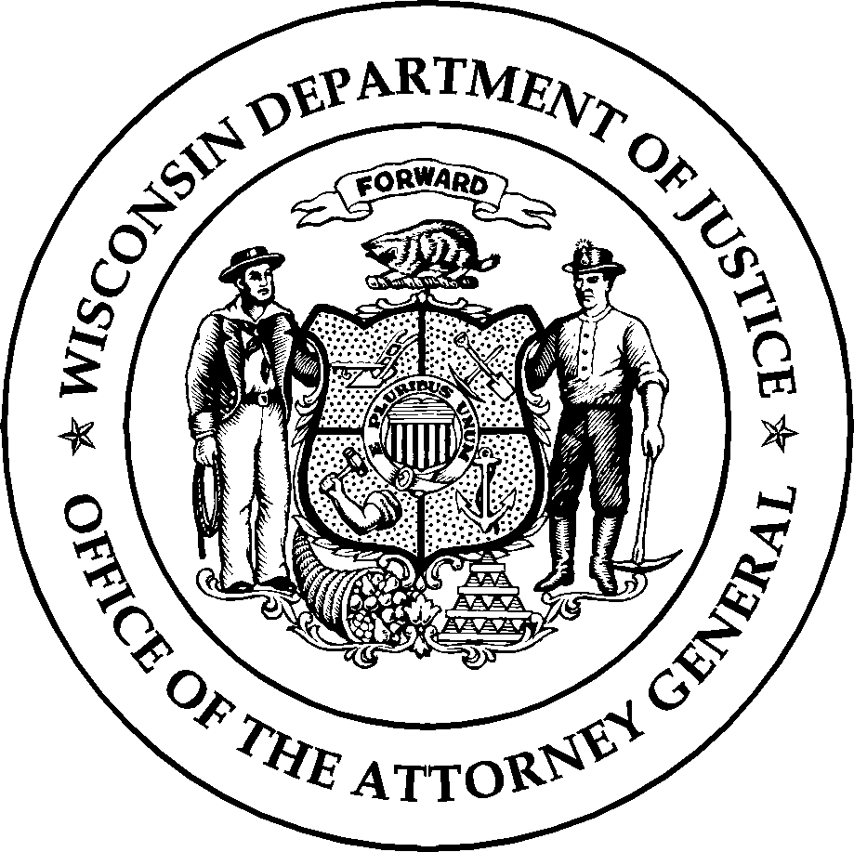
Wisconsin Department of Justice Law Enforcement Standards Board DJ‐LE‐342, 3/2021
www.wilenet.org

APPLICATION FOR EXTENSION OF THE TIMEFRAME TO REGAIN OFFICER EMPLOYMENT

According to Wisconsin Administrative Code §§ LES 3.05(4) and (6), a law enforcement, tribal law enforcement, jail or secure juvenile detention officer who has been out of law enforcement, tribal law enforcement, jail, or secure juvenile detention officer employment for over three (3) years shall be required to successfully complete the appropriate basic preparatory course for their specialty. The Wisconsin Law Enforcement Standards Board (LESB) may establish other requirements it deems appropriate (including extending the three-year timeframe) on an individual
case-by-case basis.

Applications for an extension must be approved by the LESB. The LESB meets on the first Tuesday in March, June, and December, and the first Wednesday in September. Applicants will be notified of the LESB’s decision within 15 days following the LESB meeting in which their request is considered.

1. Applicant Name (Last Name, First Name, Middle Initial):

2. Applicant Phone Number: | 3. Applicant E-mail Address:
4. Name of Last Law Enforcement, Tribal Law Enforcement, Jail, or Juvenile Detention Employer, City, and State:

5. Last Position Held (Law Enforcement, Tribal Law Enforcement, Jail, Juvenile Detention Officer, etc.):

6. Dates of Employment with Last Law Enforcement, Tribal Law Enforcement, Jail or Juvenile Detention Employer:

7. Wisconsin Agency Applied For: | 8. Position Applied For (Law Enforcement Officer, etc.):
9. Justification for Extension Request:

If approved, a condition of approval will be the requirement that the applicant successfully complete the Wisconsin Law Enforcement or Jail Officer Reciprocity Examination within one year. Applicants may include a letter or letters of endorsement with this application.

Applications may be submitted via email attachment to: mullenge@doj.state.wi.us
‐or‐
Applications may be mailed to:
Training and Standards Bureau, PO Box 7070, Madison, WI 53707‐7070

