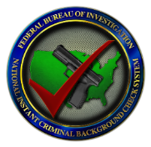

Method of Outreach

When a NICS check is initiated for a potential firearm transferee under the age of 21, the NICS Section will send a request (sample provided) to the identified points of contact requesting relevant juvenile information. Outreach to the points of contact identified for the potential juvenile criminal/delinquency information and the juvenile mental health adjudication/commitment information will be conducted through the established method as directed by the individual agency (i.e. e-mail). Outreach to local law enforcement for juvenile information will be made to the appropriate law enforcement agency based on the city, state, county, and zip code combination of the address provided by the individual to the firearms dealer. These requests will be delivered via a National Crime Information Center (NCIC) $.H.U21 unsolicited message.

Due to the passage of the Bipartisan Safer Communities Act of 2022 (hereinafter “Act”), public law 117-159, the NICS Section will conduct additional outreach for NICS background checks initiated at a federal firearms licensee when the potential firearm transferee is under the age of 21. The additional outreach is to determine if the person has juvenile criminal/delinquency information or juvenile mental health adjudications/commitments that may be disqualifying for the receipt or possession of firearms under subsection (d) of Title 18, United States Code, section 922. The Act directs NICS to immediately contact the criminal history repository or juvenile justice information system, as well as the appropriate state custodian of mental health adjudication information in which the person resides.  In addition, the legislation requires NICS to contact local law enforcement agencies of the jurisdiction in which the person resides.

Purpose of Outreach

*Expanded Outreach for Potential Firearm Transfers to Individuals Under the Age of Twenty-one*

National Instant Criminal Background Check

System (NICS) Section

**UNCLASSIFIED**

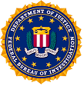

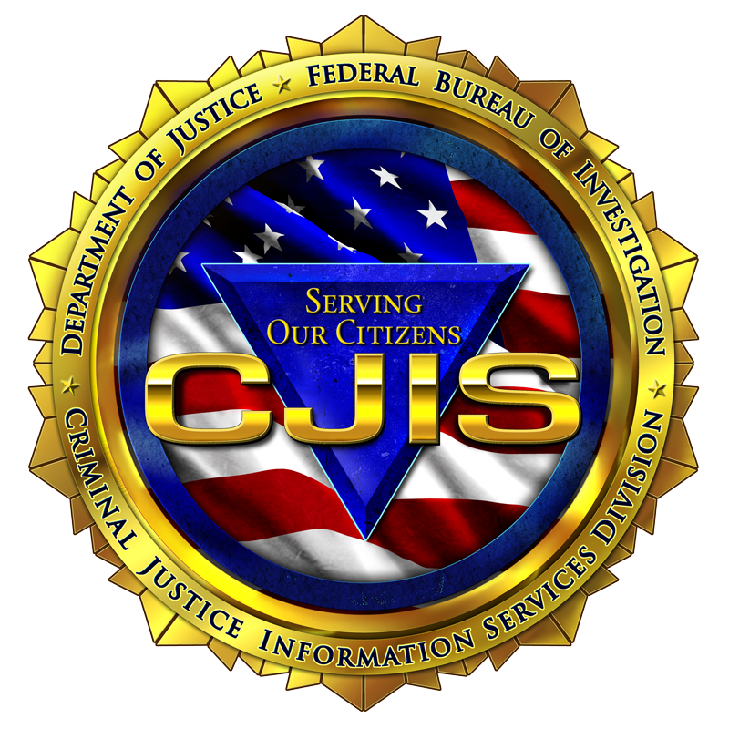

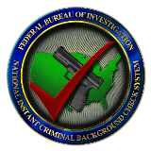

**UNCLASSIFIED**

If your agency receives a request for potential juvenile information (sample provided), your timely response indicating potentially prohibiting information exists or may exist could make the difference to the safety of the individual and the safety of your community. If your agency determines prohibiting information is not available, or that your agency is not permitted to share juvenile information for firearm-eligibility determinations, a timely response advising of such is equally important. Agencies are asked to also share information on other potentially applicable federal, state, tribal, or local firearm prohibitions such as information establishing the potential firearm transferee as a current user of controlled substance, or a respondent of an extreme risk protection order, etc. The NICS Section is available at 844-265-6716 or NICSLiaison@fbi.gov to assist agencies with questions regarding firearm prohibitions and/or discuss methods of making information available to NICS.

The sharing of juvenile criminal/delinquency and juvenile mental health adjudication/commitment information to NICS is only used for approved NICS purposes, Please consider any restriction imposed by state or agency laws before providing juvenile information when appropriate.

Created by: The NICS Business and Liaison Unit/November 2022

Your Response is Important

**UNCLASSIFIED**

Created by: The NICS Business and Liaison Unit/ October 2022

**UNCLASSIFIED**



Created by: The NICS Business and Liaison Unit/November 2022

Questions? Contact the NICS Business and Liaison Unit at: 844-265-6716 or NICSLiaison@fbi.gov

*The following is an example of the request the NICS Section will send to the identified points of contact:*

In accordance with the Bipartisan Safer Communities Act, when individuals under 21 years of age seek the transfer of a firearm through a federal firearms licensee, the FBI’s National Instant Criminal Background Check System (NICS) Section is required to contact your agency for information. We are primarily reaching out to you seeking relevant *juvenile* information on the subject below. However, if you have knowledge of or possess *any* information that could impact the subject’s eligibility to receive a firearm, we request you provide such information as well or make us aware by emailing NICS_U21@fbi.gov.

Please respond to this request within three business days, including the NICS Transaction Number (NTN) listed below. Please indicate whether your agency does/does not possess prohibiting information or whether your agency has knowledge of potentially prohibiting information.

Name Last, First M NTN

Sex

Race

Date of Birth

Place of Birth

Height Weight

Social Security Number

Residence Address:

The types of information you may possess include, but are not limited to, an inference of drug use within the past year, active warrants, active protection orders, pending or convicted criminal cases, or mental health adjudications. If a mental health adjudication is located and cannot be shared directly with the NICS Section, please indicate this in your email response. If you have questions regarding this request, please provide a name and phone number and the NICS Section will contact your agency for further discussion.

*Please note (in regards to mental health adjudications): The Health Insurance Portability and Accountability Act of 1996 (HIPAA) Privacy Rule, Title 45, Code of Federal Regulations, section 164.512(k)(7), was amended in 2016 (81 Federal Register 382-01) to allow covered entities to disclose protected health information to the NICS without requiring the individual’s consent, in order to report the identities of individuals who are prohibited from shipping, transporting, possessing, or receiving a firearm based on the federal “mental health prohibitor,” Title 18, United States Code, section 922(g)(4).*

**UNCLASSIFIED**

Example of Request for Potential Juvenile Information

National Instant Criminal Background Check

System (NICS) Section



**UNCLASSIFIED**